**ACTIVITY NO. 1**

**Programming Language**

**Topic: Algorithm**

**09/09/2025**

**Q.1: How can you break down the trip planning process into smaller, manageable tasks? (Decomposition)**

We can divide the trip planning into smaller tasks:

i. Decide travel dates and duration.

ii. Arrange transportation (car/bus booking).

iii. Book accommodation (hotel/guest house).

iv. Plan budget (fuel, food, stay, activities).

v. Make a list of essentials to pack (clothes, medicines, documents).

vi. Plan sightseeing spots in Murree (Mall Road, Patriata, Kashmir Point).

vii. Ensure safety measures (weather check, emergency numbers).

**Q.2: What patterns can you identify from your past travel experiences? (Pattern Recognition)**

Trips usually require transportation + accommodation + food + activities.

Unexpected weather changes often happen in hill stations.

Packing essentials (warm clothes, medicines) is always required.

Budget planning helps avoid overspending.

Pre-booking hotels avoids last-minute problems.

**Q.3: What are the essential elements to consider when planning a trip? (Abstraction)**

Focus on the main important elements:

Time (weekend, so only 2–3 days).

Budget (limit expenses, include emergency money).

Transport & Stay (comfortable and safe).

Weather conditions (Murree is cold, pack accordingly).

Food & health (restaurants, medicines).

Activities (sightseeing, shopping, photography).

**Q.4: How can you create a step-by-step plan to ensure a successful trip? (Algorithm Design)**

Step-by-Step Algorithm:

Step 1: Fix travel dates (Friday evening to Sunday night).

Step 2: Decide transport (own car or book a van/bus).

Step 3: Book hotel in advance.

Step 4: Make a packing list (warm clothes, shoes, medicines, camera, ID cards).

Step 5: Estimate budget and keep extra money for emergency.

Step 6: Travel to Murree and check-in at hotel.

Step 7: Visit main attractions (Mall Road, Kashmir Point, Patriata chairlift).

Step 8: Take meals on time and ensure safety during sightseeing.

Step 9: Return home safely on Sunday evening.

**Activity No.2**

**Programming Language**

**Topic: Python**

**09/09/2025**

**CODE 1:** Write a program to check if a number is positive, negative, or zero.

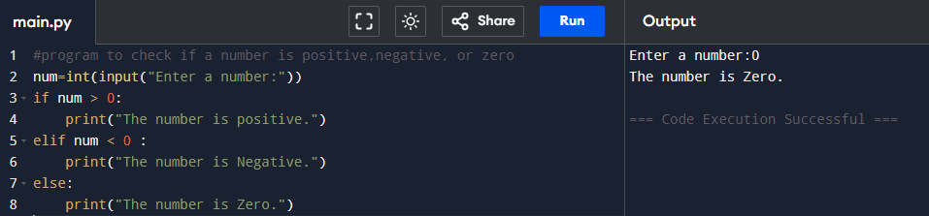

**CODE 2:** Create a program to determine whether a given year is a leap year.

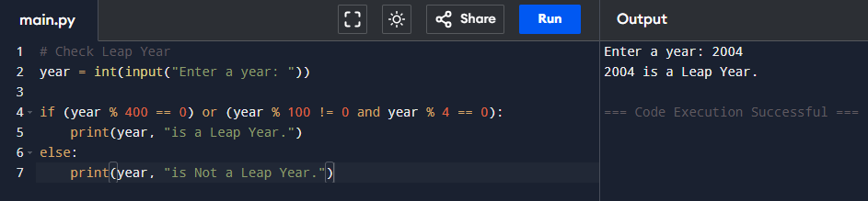

**CODE 3:** Build a simple calculator that asks for two numbers and an operator ( + , -, *, / ) and prints the result.

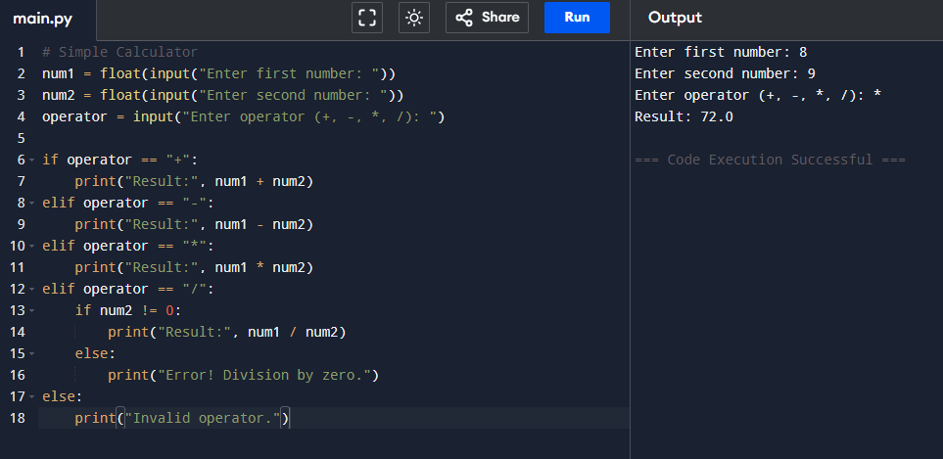

**CODE 4:** Write a Python program that accepts a student’s marks and prints the apptopriate grade based on the following criteria:

A: 85 and above

B: 70 to 84

C: 50 to 69

F: Below 50

